Stoptober 2024 – Partnership Pack

This year, Stoptober is back with a new national campaign: ‘if you quit smoking for Stoptober (i.e. 31 days) you are five times more likely to quit for good.’
The latest data shows that using willpower alone remains the most common approach to quitting, despite being proven to be the least effective. Stoptober is a great opportunity to promote the range of national and local support available and, as a result, increase the number of successful quit attempts.
The total cost from smoking to society in England is approximately £21.8 billion each year, which includes a cost to the NHS of approximately £1.9 billion per year to treat smoking-related diseases. 😮

Local Staffordshire Campaign with Everyone Health Staffordshire
Staffordshire County Council commission ‘Everyone Health Staffordshire’ to provide a free stop smoking service. This includes FREE face to face or telephone support and FREE nicotine replacement therapies (patches, gum, vapes etc) for people aged 18 and over who live in Staffordshire (excludes Stoke-on-Trent).

NEW for 2024 – Everyone Health can now offer FREE:
- Cytisine tablets to under 60s to help with withdrawal symptoms
- Vapes to aid quitting – Totally Wicked vapes with refills included

Here’s a new short video reminder of what they can offer along with advice and guidance: https://youtu.be/l2rOibn9rUU

There are a lot of myths around vapes and these are addressed on the NHS website: Vaping myths and the facts - Better Health - NHS (www.nhs.uk)

TIMESCALES

- w/c 16th September -30th September – Prepare Phase
- 1st October –31st October – Support and Action Phase

HOW CAN YOU SUPPORT THE CAMPAIGN?
Please help us support Staffordshire residents in their quit journey by liking and sharing the content posted on Staffordshire County Council’s social media channels by searching #stoptober or by clicking the links below and pressing share.

- Facebook - (4) Facebook
- X/Twitter – look out for our news story next week.

We will be also doing some video posts, so look out for these.

SOCIAL MEDIA – w/c 16th September

With less than two weeks to go before #Stoptober starts, are you, ready to quit?  ✅ Think of your reason to quit and write it down. Put it where you normally keep your cigarettes.  ✅ Tell people you’re quitting  ✅ Set a quit date and stick to it  ✅ Get FREE support and free stop smoking aids (patches, gum, inhalators and vapes) from @EHStaffordshire.  Text: QUIT to 60777 or call: 0333 005 0095. | 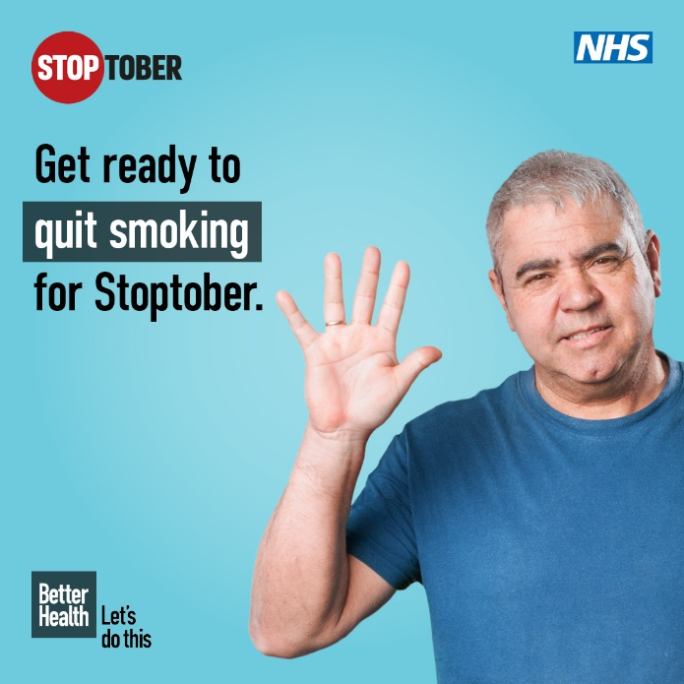  or share this animated post: (4) Facebook
w/c 23rd October  Kickstart your #Stoptober journey with the #Staffordshire Health App Finder.  Discover a world of the best rated and safest apps to help you #quitsmoking for good.  Commit to quit with ➡️ staffordshire.gov.uk/appfinder | 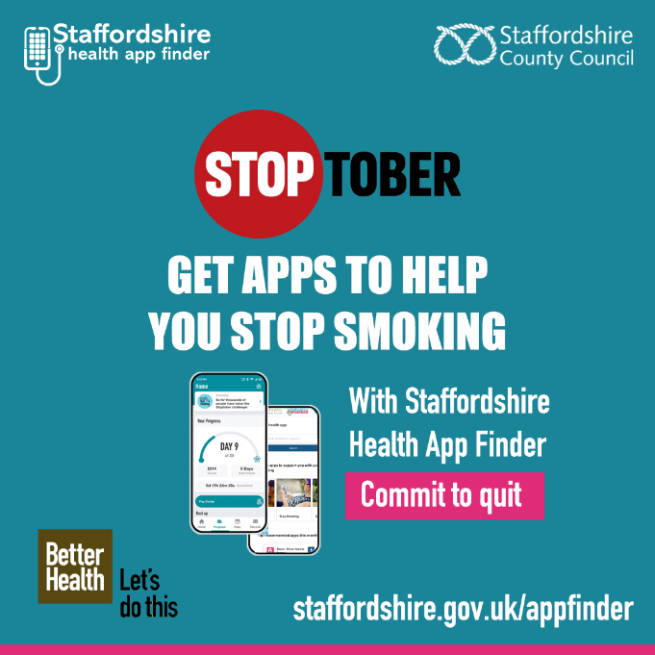
SOCIAL MEDIA – w/c 1st October  #Stoptober starts today!  If you quit smoking for Stoptober (October) you are five times more likely to quit for good!  Get FREE support and free stop smoking aids (patches, gum, inhalators and now vapes) from @EHStaffordshire.  Text: QUIT to 60777 or call: 0333 005 0095 and set your quit date today! | 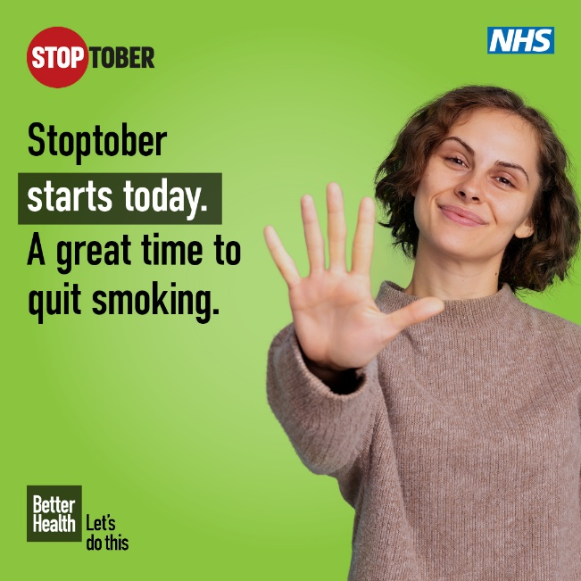  Look out for our video as well

DIGITAL
Updated digital screens that can be displayed on TV screens in GP waiting rooms, hospitals or other health care settings are available.

Staffordshire offer digital screen (also attached to email)

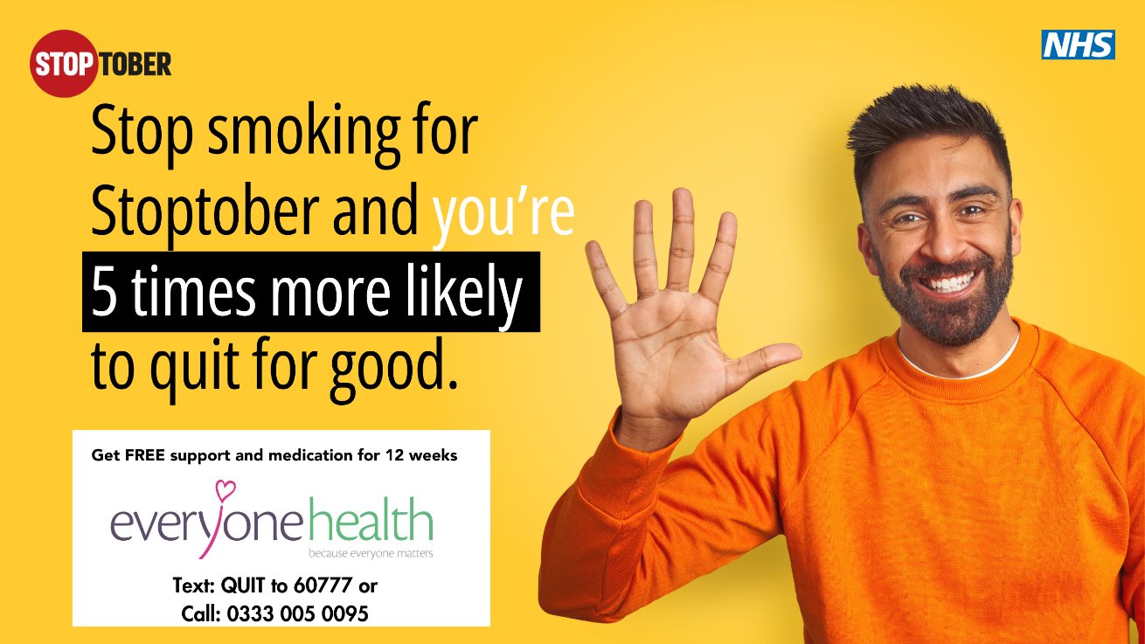

National Resources
There are animations of the above posts and other resources available from Campaign Resource Centre (phe.gov.uk)
If you need more information, email me leonie.ohanlon@staffordshire.gov.uk
Everyone Health helped me to quit in 2021, and I’m still smoke free!
The names of people contacting the service are not shared with us. So, if you’re a smoker, please call Everyone Health Staffordshire or text: QUIT to 60777

They can help even if you only have a few cigarettes and vape as well. Or, if you previously had help and did not succeed – maybe the vapes or new medication will help you quit for good.

